WEEK 1 REPORT:
Superstore Sales Data Import, Power Query & Data Cleaning
Introduction:
In this week, I worked with the Superstore Sales dataset using Power BI Desktop. The main aim was to import the dataset, inspect the data, clean the columns, and prepare the data for analysis. Data cleaning helps to make the data accurate, consistent, and ready for creating reports and dashboards.
Data Import into Power BI
- I opened Power BI Desktop.
- I imported the Superstore Sales dataset into Power BI.
- The data was loaded successfully.
- I explored the different views available in Power BI.
- Report View is used for creating visuals.
- Data View is used to see rows and columns.
- Model View is used to view relationships between tables.
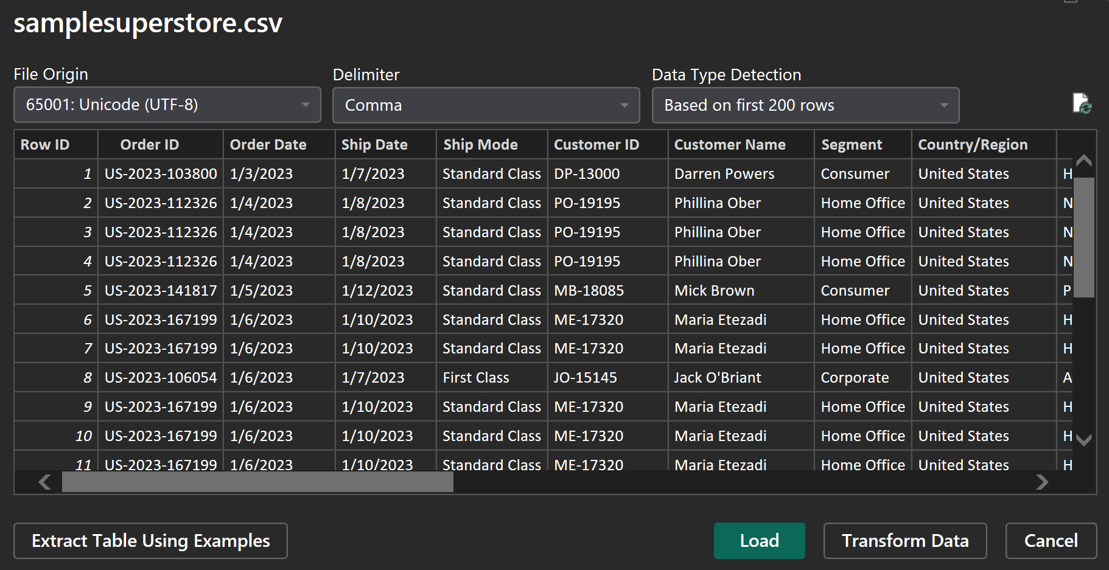
Data Inspection using Power Query
- I opened Power Query Editor to inspect the dataset.
- I checked the data types of the columns.
- I checked for blank and missing values.
- I checked the data quality of the columns.
- This helped me identify the cleaning and transformation required.
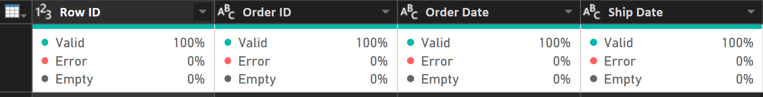
Data Cleaning and Transformation
- I checked and corrected the data types of the columns.
- Text values were cleaned to remove unnecessary spaces.
- The columns were made consistent and easier to use.
- Date and numeric columns were properly recognized.
- These changes improved the quality and readability of the dataset.
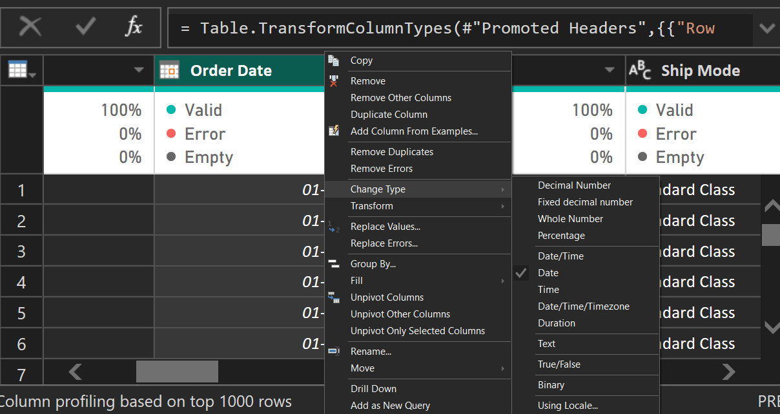

Standardizing Categorical Data
- I worked on the Category, Sub-Category, and Segment columns.
- I cleaned the text values and removed extra spaces.
- The categorical values were made consistent.
- This helps in proper grouping and filtering during analysis
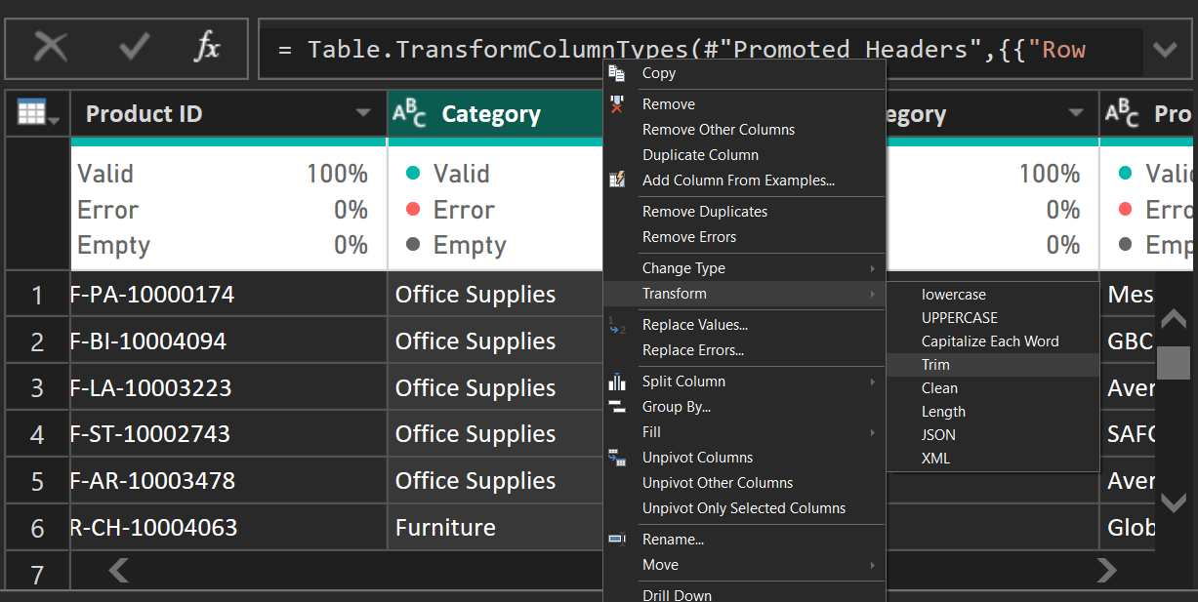
Date Attribute Extraction
From the Order Date column, I created useful date attributes:
- Year – for yearly analysis.
- Quarter – for quarterly analysis.
- Month Name – for monthly analysis.
- Day – for daily analysis.
- Day of Week – for analyzing transactions by day.
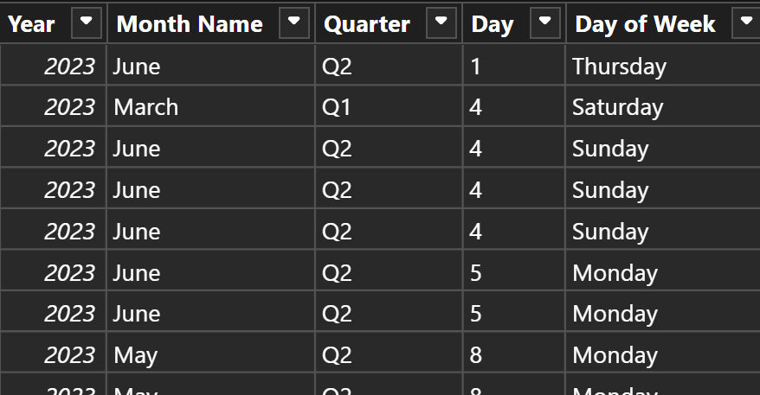
Loading and Finalizing the Clean Data Model
- After completing the cleaning and transformations, I selected Close & Apply.
- The cleaned data was loaded back into Power BI.
- I checked the Data View to confirm the transformed columns.
- The dataset was now ready for further analysis and dashboard creation.
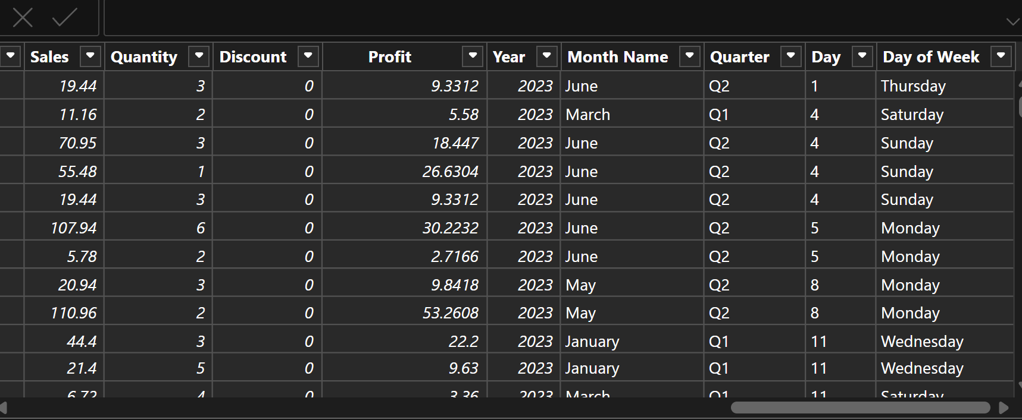

Result
The Superstore Sales dataset was successfully imported and cleaned using Power BI. The required categorical and date attributes were created, and the final dataset was prepared for further analysis and visualization.
Conclusion
This week's activity helped me understand the basic process of data importing, inspection, cleaning, transformation, and date attribute creation in Power BI. The cleaned dataset provides a good foundation for creating dashboards and performing further analysis.

